NIP Project — Submission
Section 1 — Your Details
Full Name | Nandhitha PT
Email ID (registered on NIP) | nandhithapalanisamy11@gmail.com
Phone Number | 8508570331
College Name | V.S.B. Engineering college, Karur
Course (e.g. IT, CS) | CSE(AIML)
State | Tamil Nadu
Project Chosen (Vehicle Service OR Movie Ticket Booking) | Movie Ticket Booking
Pega Application Name (e.g. NIP-VehicleService-YourName) | Movie_Ticket_Booking_Management_Application_Nandhitha_PT
Case Type Name (exact) | Ticketing Management
Pega Instance URL | https://xlxasjgr.pegaacademy.net/prweb/
Operator Name (created in Pega with your full name) | Nandhitha_PT

Section 2B — Movie Ticket Booking Management Application
US-001 — Submit Movie Ticket Request
What is expected:
Case created, customer submits Movie Name, Show Date, Show Time, Number of Tickets. Validation applied.
Screenshot:
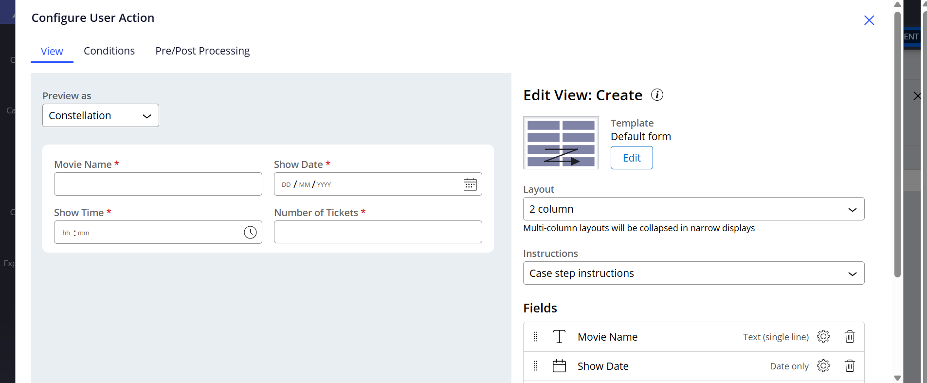
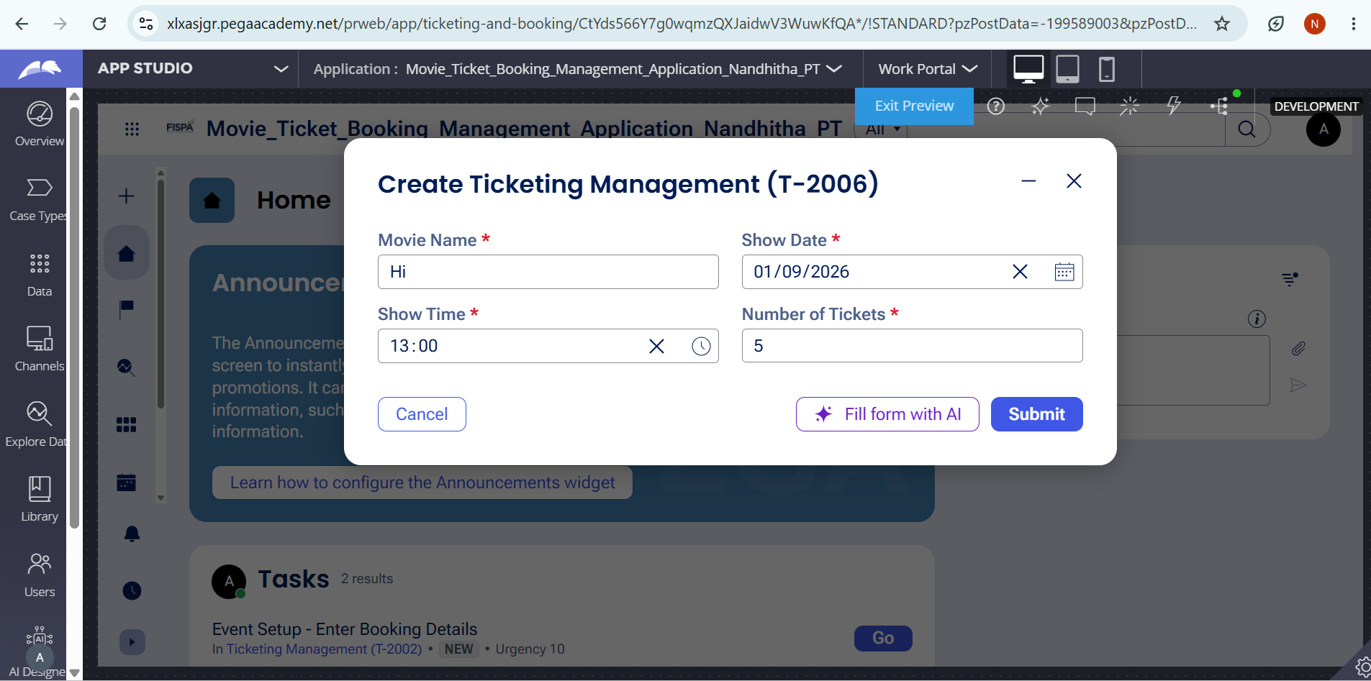

What I built for this
I created a movie ticket booking request form where the customer enters the Movie Name, Show Date, Show Time, and Number of Tickets. I also added validation to ensure the required booking details are entered before the request is submitted.

US-002 — Check Show Availability
What is expected:
Availability stage. Seat Availability Status and Available Seats Count captured. Booking proceeds only if available.
Screenshot:
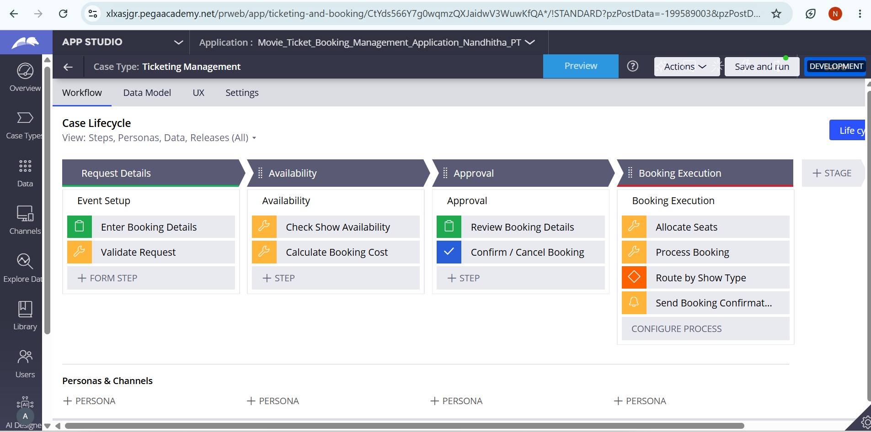

What I built for this :
I created an Availability stage that checks the Seat Availability Status and Available Seats Count. The booking proceeds only when the required number of seats is available.

US-003 — Calculate Booking Cost
What is expected:
Total Cost calculated automatically from Ticket Price and Number of Tickets using a business rule.
Screenshot:
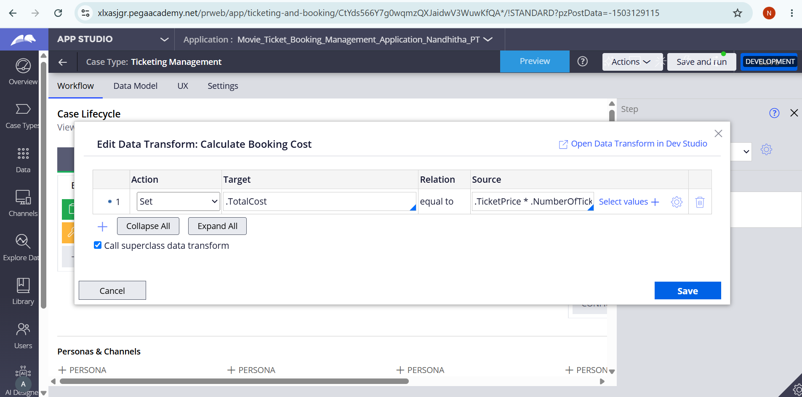

What I built for this:
I created a calculated Total Cost field that automatically calculates the booking cost using Ticket Price × Number of Tickets. The calculation is configured as a read-only field, so the Total Cost is generated automatically.

US-004 — Confirm Booking Request
What is expected:
Approval stage assigned to Customer. Booking Status captured. Flow branches on confirm/cancel.
Screenshot:
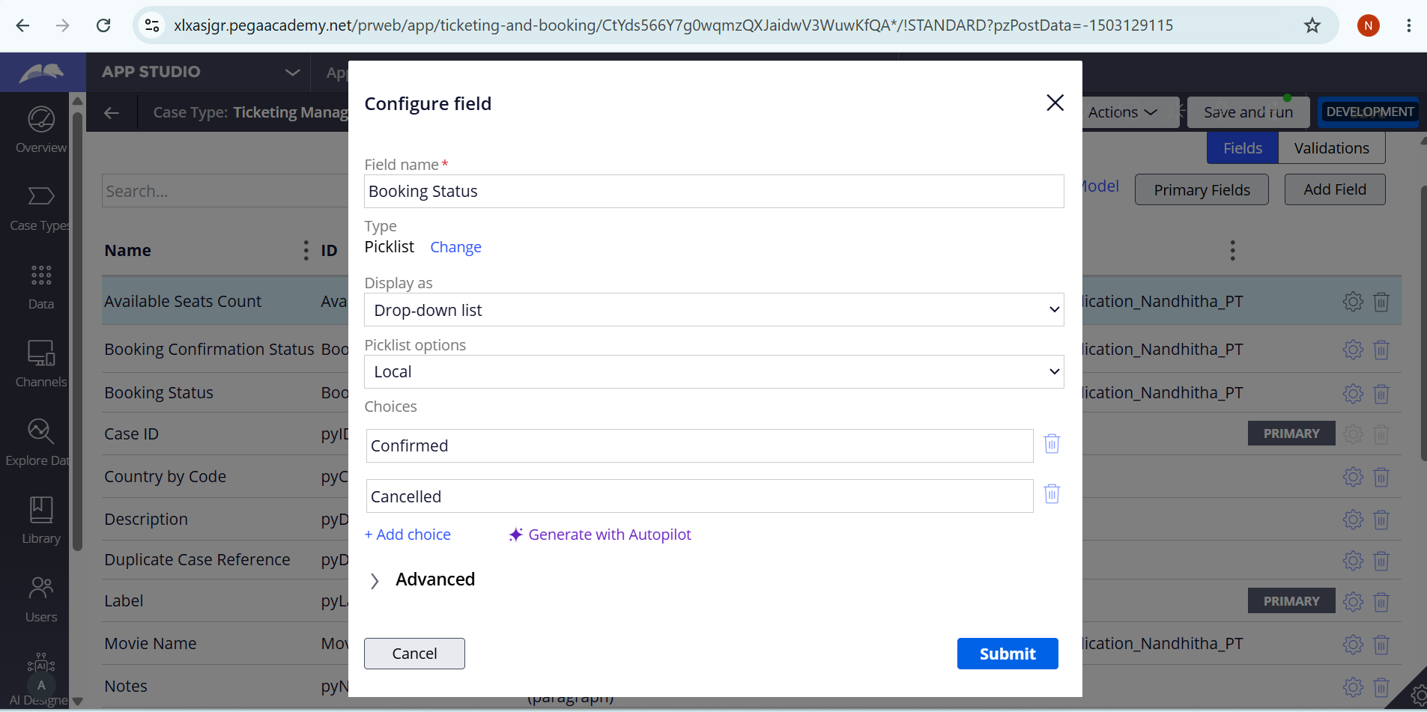

What I built for this :
I created an Approval stage assigned to the Customer where the customer can review the booking and select Confirmed or Cancelled as the Booking Status. The workflow then branches based on the selected status and proceeds with the appropriate action.

US-005 — Maintain Movie and Show Data
What is expected:
Reusable Movie and Show data objects created with Movie Name, Genre, Show Date, Show Time, Seat Capacity — linked to case.

Screenshot:
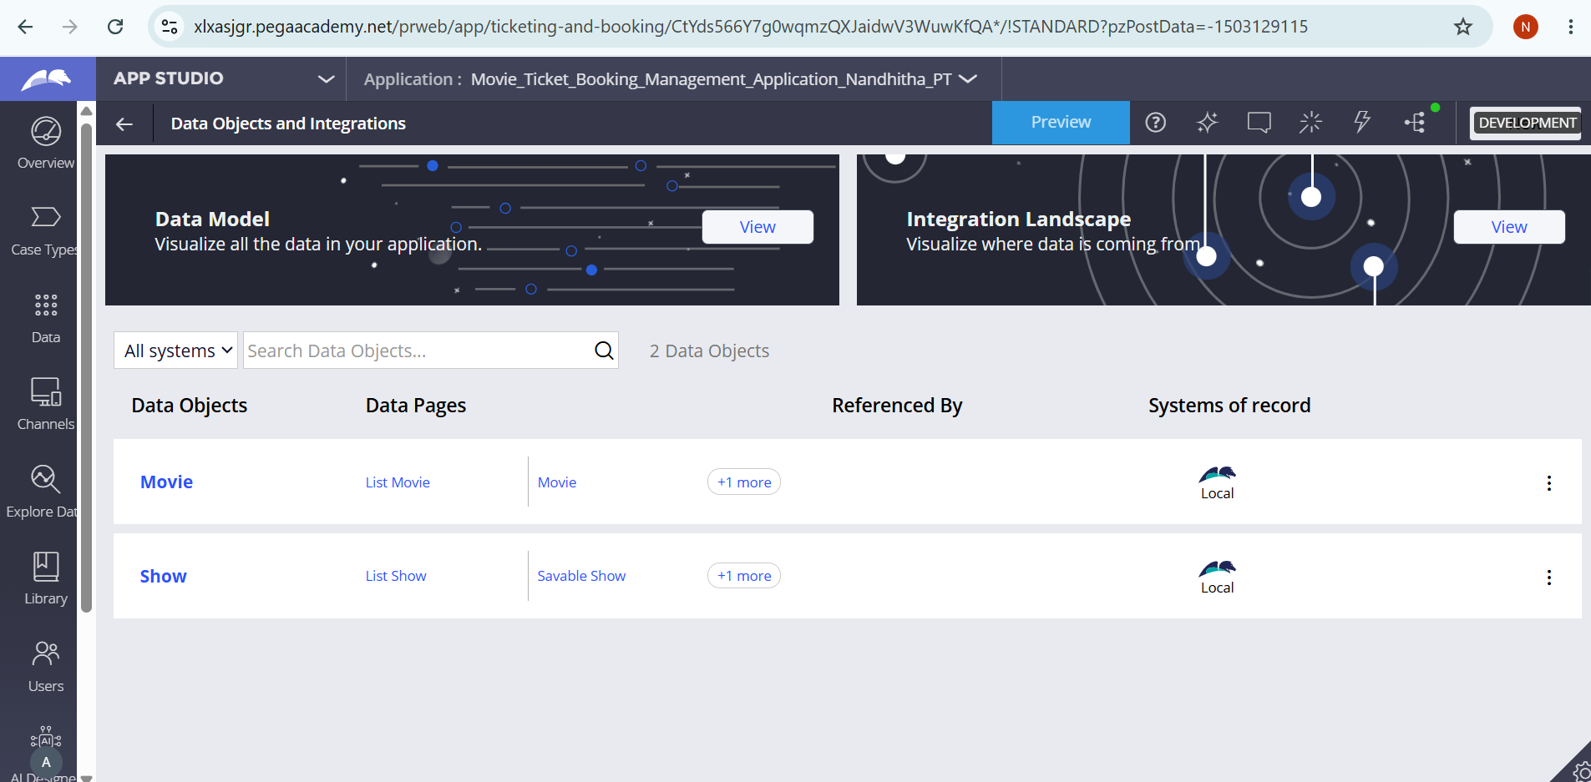

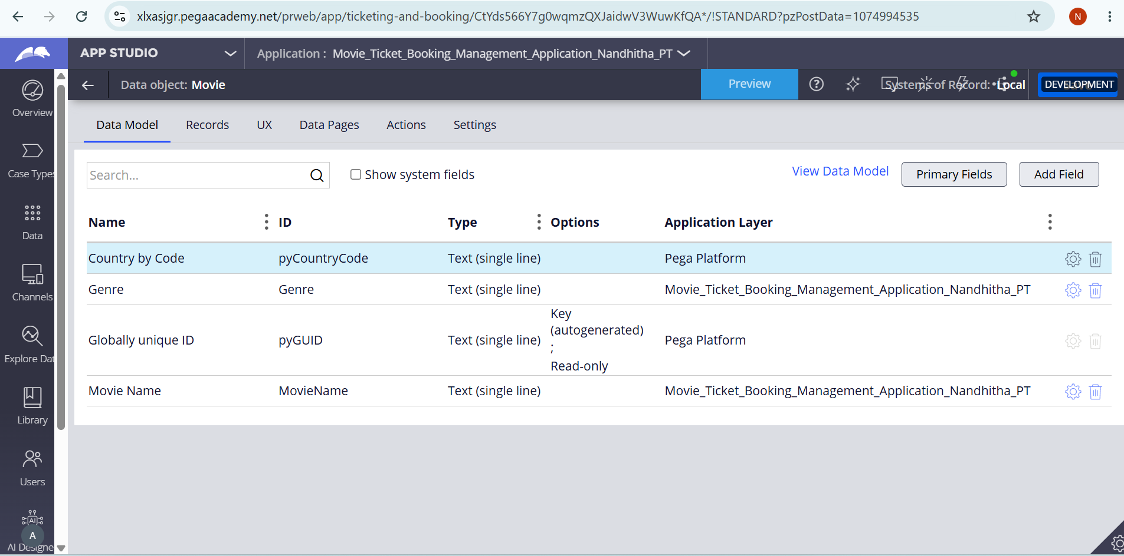

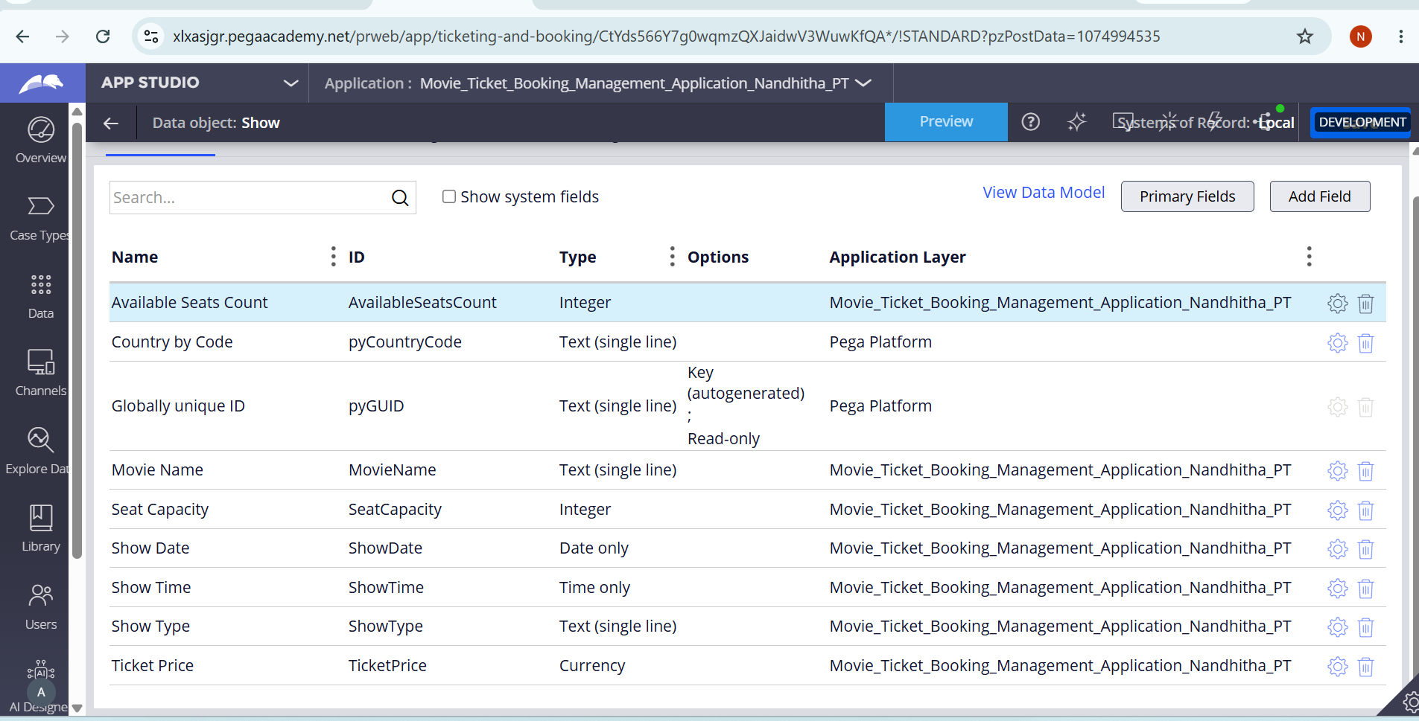

What I built for this :
I created reusable Movie and Show data objects to maintain movie details such as Movie Name, Genre, Show Date, Show Time, and Seat Capacity. These data objects can be used and linked to the ticket booking case.

US-006 — Review Booking Details
What is expected:
Confirmation screen shows Movie Name, Show Timing, Number of Tickets and Total Cost clearly.
Screenshot:
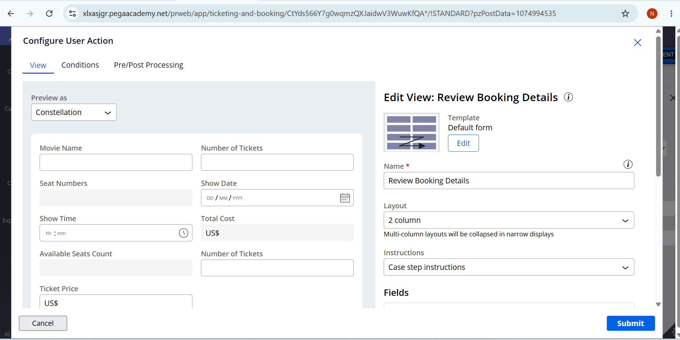

What I built for this:
I created a Review Booking Details screen that clearly displays the Movie Name, Show Date, Show Time, Number of Tickets, and Total Cost before the booking is confirmed.

US-007 — Process Ticket Booking
What is expected:
Booking Execution stage. Seat Numbers, Ticket ID and Booking Confirmation Status maintained.
Screenshot:
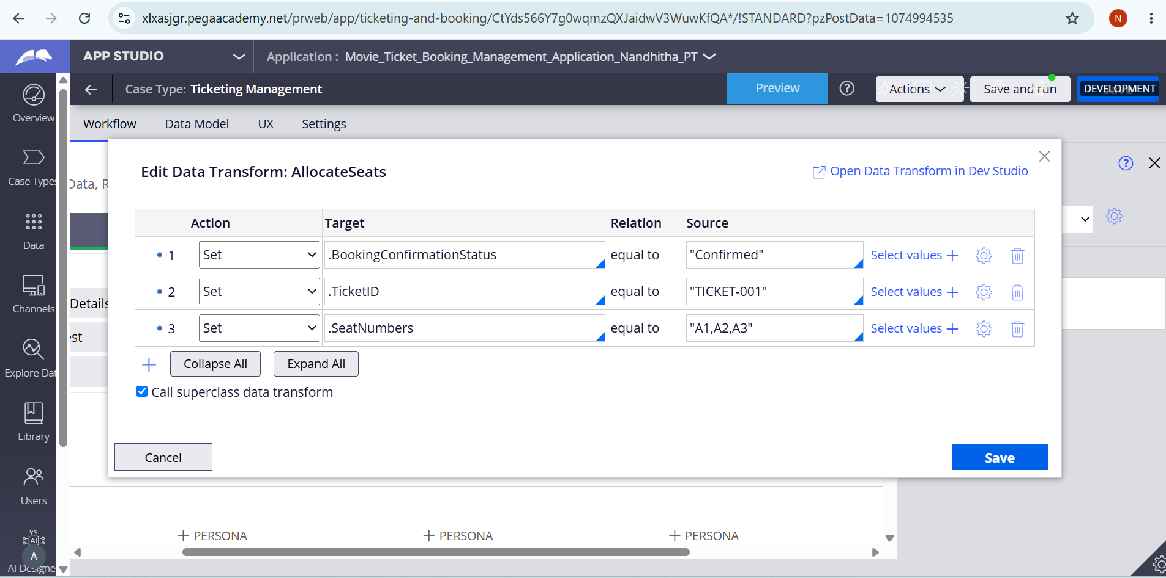

What I built for this:
I created a Booking Execution stage that processes the ticket booking and maintains the Seat Numbers, Ticket ID, and Booking Confirmation Status. These details are updated after the booking is successfully processed.

US-008 — Notify Booking Confirmation
What is expected:
Correspondence rule triggered on case resolution. Email includes movie, show, seat and cost details.
Screenshot:
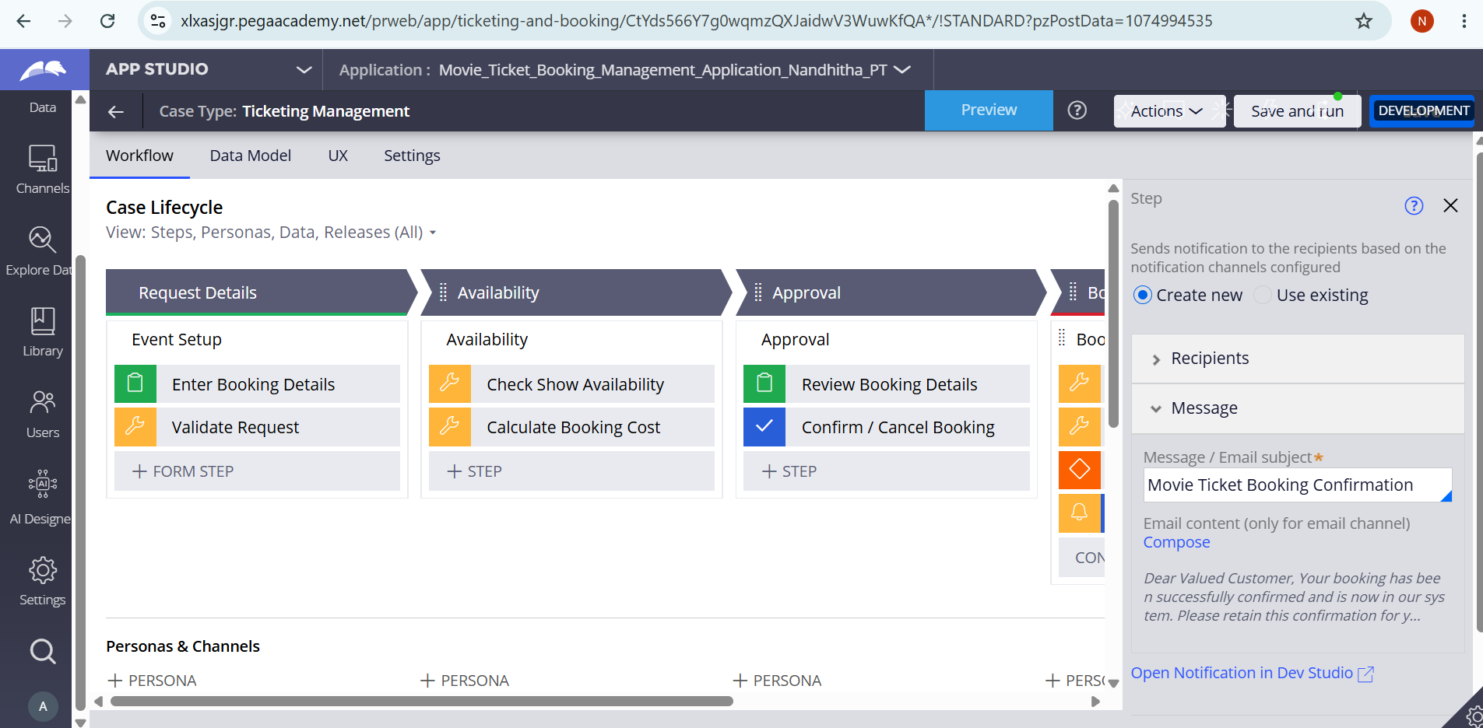

What I built for this (1–2 lines in your own words):
I configured a booking confirmation email that is triggered after the booking is completed. The email includes the Movie Name, Show Timing, Seat Numbers, and Total Cost so the customer receives all booking details.

US-009 — Define Booking SLA
What is expected:
SLA configured on the case type. Goal: 1 day. Deadline: 2 days. Priority increases on breach.
Screenshot:
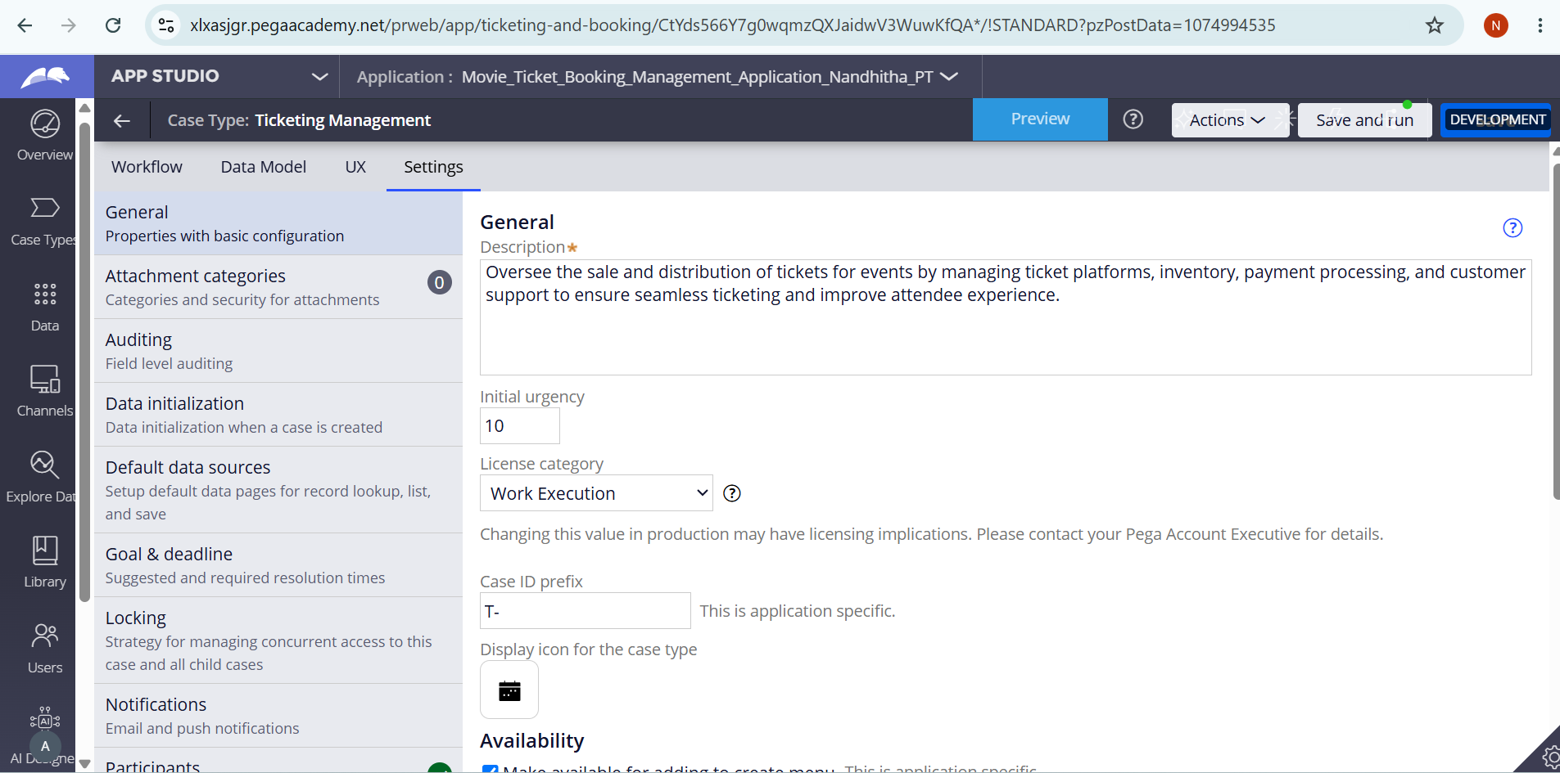

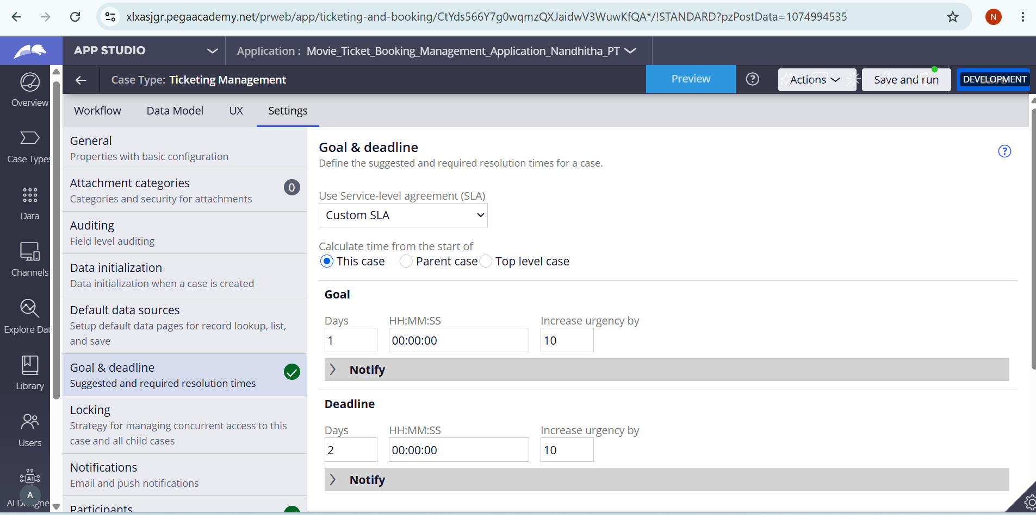

What I built for this (1–2 lines in your own words):
I configured a Custom SLA for the Ticketing Management case with a goal of 1 day and a deadline of 2 days. The urgency is increased by 10 when the goal or deadline is breached.

US-010 — Route by Show Type
What is expected:
Routing rule or Decision Table routes to PremiumShowQueue or StandardShowQueue based on Show Type property.
Screenshot:
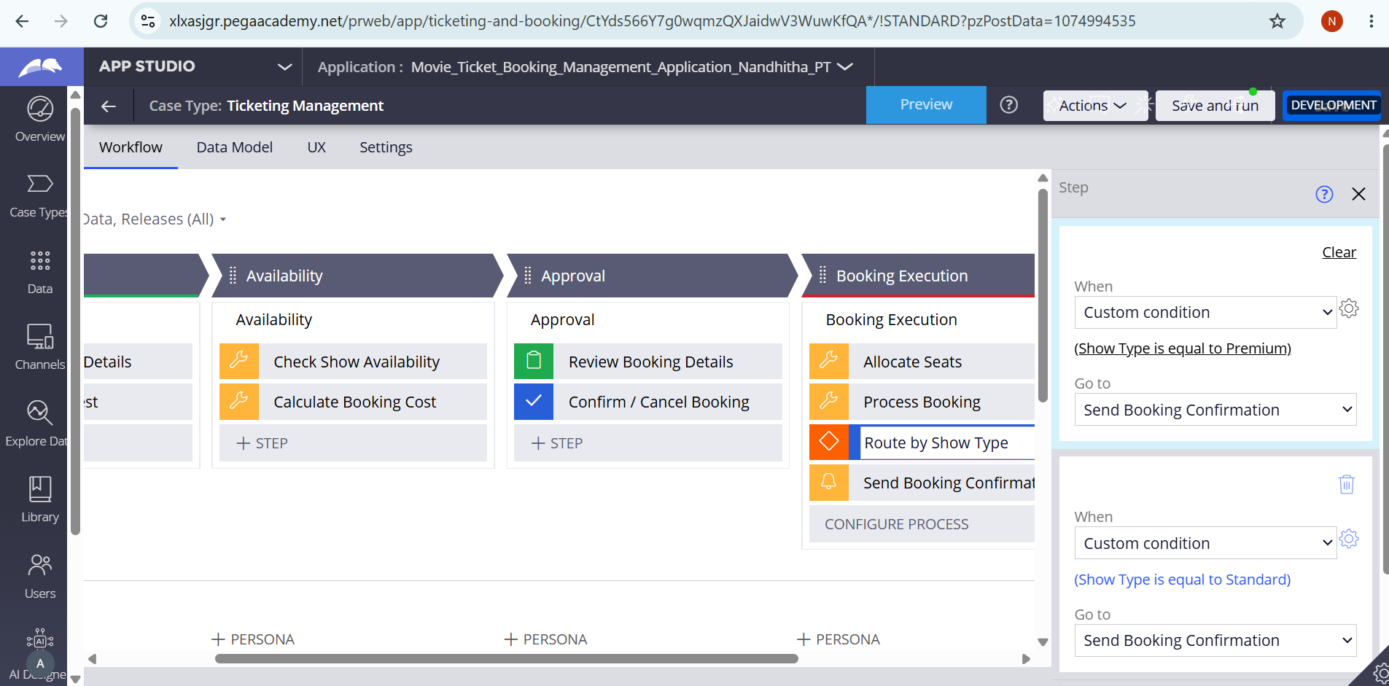

What I built for this:
I configured a routing rule based on the Show Type property. Premium shows are routed to PremiumShowQueue, while Standard shows are routed to StandardShowQueue.

Section 3 — About Your Application
Q1. List your stages in the order they appear in your case lifecycle.
Stage names in order, separated by commas.
Request Details, Availability, Approval, Booking Execution

Q2. Name the data object(s) you created and the properties inside them.
Data object name and its properties.
Ticketing Management case data — Movie Name, Show Date, Show Time, Show Type, Ticket Price, Number of Tickets, Seat Availability Status, Available Seats Count, Seat Numbers, Ticket ID, Booking Status, Booking Confirmation Status, and Total Cost.

Q3. What is the exact name and type of the rule you used to calculate Total Cost?
Provide:
• Rule Name
• Rule Type
• Properties used in the calculation
• Formula used
Rule Name: Calculate Booking Cost
Rule Type: Data Transform
Properties used: Ticket Price and Number of Tickets
Formula: Total Cost = Ticket Price × Number of Tickets

Section 4 — Your Understanding
Short, honest and specific answers score well.

Q4. What did Blueprint generate for you, and what did you add or change yourself afterwards?
Be specific about what was already there and what you built or modified on top.
Blueprint generated the initial Movie Ticket Booking case structure and workflow. I then configured and modified the case by adding the required booking fields, availability and cost calculations, confirmation/cancellation flow, seat allocation, show-type routing, booking notification, and SLA settings.

Q5. Was there anything Blueprint created that you had to correct or configure further? Describe one example.
A real example from your own work.
Yes. One example was the CheckShowAvailability data transform. The generated configuration contained invalid property references, so I corrected the target fields and values. I also corrected the conditions so that the availability and show-type logic used valid case properties.

Q6. Explain your case flow from creation to resolution, in order.
What happens first, who does what, when the case closes.
The customer first submits the movie name, show date, show time, and number of tickets in the Request Details stage. The request is validated and show availability is checked in the Availability stage, where seat availability and booking cost are handled. The case then moves to the Approval stage, where the booking details are reviewed and the customer confirms or cancels the booking. If confirmed, the case moves to Booking Execution, where seats are allocated, the booking is processed, the request is routed according to show type, and a booking confirmation notification is sent. The case is then resolved.

Q7. Pick two design choices you made in your application and explain why you made them.
For each design choice, provide:
• What you implemented
• Why you chose that approach
• What benefit it provides to the application
- Automatic Total Cost Calculation — I implemented Total Cost as a calculated field using Ticket Price × Number of Tickets. I chose this approach so that the customer does not have to manually enter the total amount. This reduces calculation errors and keeps the booking amount consistent.
- Show Type Routing — I implemented a conditional routing rule based on Show Type. Premium shows are routed to PremiumShowQueue and Standard shows are routed to StandardShowQueue. I chose this approach to separate premium and standard bookings and make the processing of each type easier to manage.

Q8. What was the hardest part, and how exactly did you fix it?
Specific and honest. A real challenge scores much better than a generic answer.
The hardest part was configuring the data transforms and routing conditions because some generated expressions used invalid property references. I checked the error messages, corrected the target properties and source values, removed invalid references, and configured the conditions using the actual case properties. I also corrected the Show Type routing so Premium and Standard were separate conditions instead of using an AND condition.

Q9. If the approval step was only needed when Total Cost is above a certain amount, what would you change in your application?
Explain what you would change and where. You do not need to build this.
I would add a condition before the Approval stage based on the Total Cost property. If Total Cost is greater than the specified amount, the case would proceed to the Approval stage. If Total Cost is below or equal to that amount, the case would bypass Approval and continue directly to Booking Execution.

Q10. List three exact rule names from your application that you personally created or modified.
Include the rule name and rule type for each one (for example: CalculateTotalCost - Declare Expression).
1. CheckShowAvailability — Data Transform
2. Calculate Booking Cost — Data Transform
3. AllocateSeats — Data Transform
Q11. List all personas used in your application.
List the persona names exactly as they appear in your application.
Customer
Booking Agent
Q12. List all work queues used in your application and explain when each one is used.
For each work queue, provide its exact name and the condition or type of work routed to it.
PremiumShowQueue — Used when the Show Type is Premium.
StandardShowQueue — Used when the Show Type is Standard.

